**Macintosh HD:Users:kaitlynslomski:Desktop:Niche:Niche:Logos:pdf:Niche_2Color.pdf**

Jill T. Slomski

President, Owner

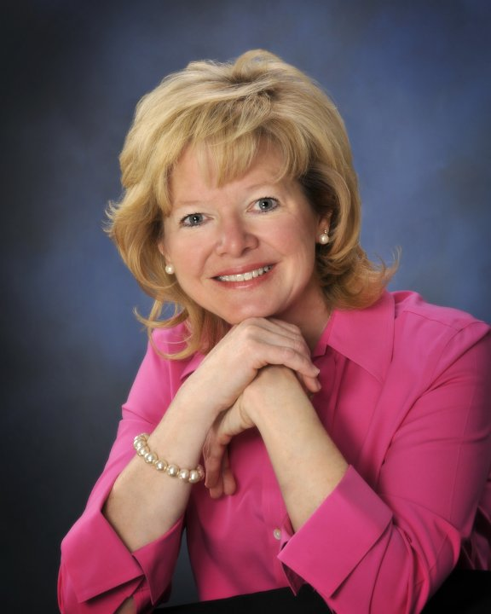With over 25 years of experience working with businesses, Jill Slomski has definitely found her Niche. Jill has developed skills and processes that help companies meet the challenges and plan for a successful future. Her clients have included a wide range of industries including manufacturers, service providers, educational organizations, healthcare, nonprofits, government, and retail.

Most recently, Jill has rebranded her own company, Niche Team, LLC, and through careful selection, has built a team of dedicated, creative professionals focused on working with companies in the areas of Strategic Planning, Marketing, Speaking & Seminars, and Conferencing. Niche can also provide training for you and your employees to sharpen skills and maintain a competitive edge in your industry.

Jill received her MBA from Gannon University, a BS in Education with a minor in Educational Psychology from Indiana University of Pennsylvania. She participates in many organizations including Athena Powerlink, and serves on many regional Boards. Jill has two children, Kaitlyn and Jonathan, and resides in Fairview, Pennsylvania.

jill.slomski@niche-team.com

814.397.5637

www.niche-team.com