Special thanks to our adult helpers for the evening!
Mrs. K. Anker, Mrs. A. Baer, Mr. M. Baer, Mrs. K. Bishop, Mrs. K. Killen.

Gateway Middle School
Cooking Club
It’s Breakfast for DINNER!
Appetizers – prepared by Mrs. Baer & Mrs. Killen: Jalapeño Popper Pinwheels & Sausage Balls. Apples with brie cheese, homemade jam and graham crackers.
Recipes that will be prepared for the meal:
Hash Browns
Veggie Frittata
Breakfast Burrito
Fluffy Pancakes with Whipped Cream and Berry Syrup
Take home goodies: Granola, Banana Crumb Muffins and Blueberry Muffins.
Most of the recipes that we used are from the site – allrecipes.com We modified some of them – ingredients, methods etc. – but the basic recipes are on that site if you want them. If you have any questions – contact Mrs. Baer – abaer@gatewayk12.org

March 7, 2014
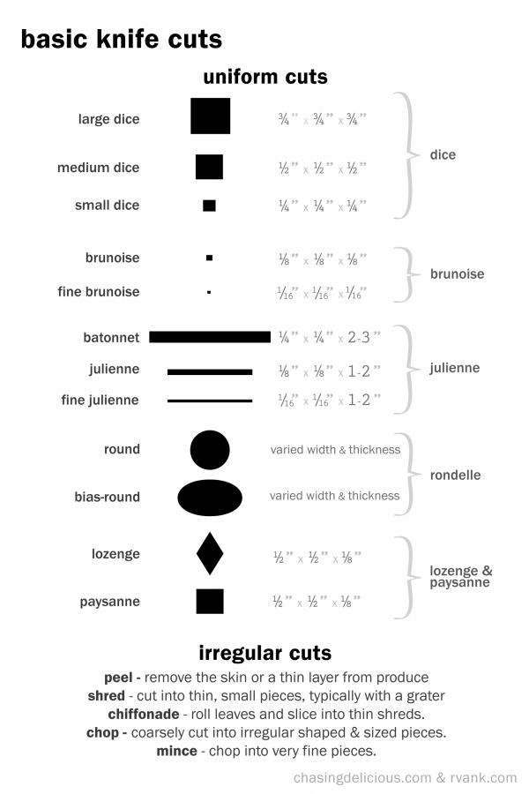

Jalapeño Popper Pinwheels
Prep time 15 mins Cook time 12 mins
Serves: 45
Ingredients
- 2 Packages Puff Pastry Sheets (thawed)
- 2 8oz packages of Cream Cheese (softened)
- 2 cups Shredded Mexican Cheese Blend or Monterrey Jack Cheese
- 2 cups diced fresh jalapeños (seeded) or you can use jarred pickled jalapeños
- ¾ tsp garlic powder
- ½ teaspoon salt

Directions:
- Preheat oven to 400 Degrees F
- In a medium bowl mix together cream cheese, cheese, jalapeños, and garlic salt until well combined.
- Carefully unfold one puff pastry sheet and roll it out a little larger. Evenly spread half of the jalapeno cheese mix over the pastry sheet. Roll it up long side to long side, pressing the seam together with a little water on your fingers to seal.
- Slice into 1 inch pieces.
- Place the rolls on a parchment lined baking sheet.
- Bake at 400 Degrees for 12 minutes or until golden brown. Repeat with the other sheets of puff pastry.
- Serve immediately
Sausage Balls Appetizer

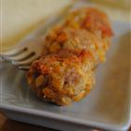 | Prep Time: 15 Minutes Cook Time: 20 Minutes Ready In: 35 Minutes Servings: 30
INGREDIENTS:
2 pounds ground pork sausage  4 cups biscuit baking mix | 2 pounds sharp Cheddar cheese, shredded
DIRECTIONS:
1. | Preheat oven to 350 degrees F (175 degrees C).
2. | In a large bowl, combine sausage, biscuit baking mix and cheese. Form into walnut size balls and place on baking sheets.
3. | Bake in preheated oven for 20 to 25 minutes, until golden brown and sausage is cooked through.
Hash Browns
(from “Emily’s Famous Hash Browns” on allrecipes.com)
Prep time: 20 minutes Cook Time: 15 minutes 24 servings

INGREDIENTS:
20 medium russet potatoes, shredded  4 medium onions, finely chopped  1 ½ cups all-purpose flour | 6 eggs  2 cups oil for frying, or as needed  salt and pepper to taste
DIRECTIONS:
1.  2.  3. | Shred potatoes on a metal shredder or in a food processor. Put potatoes in a colander and rinse shredded potatoes until water is clear, then drain and squeeze dry in a CLEAN dishtowel.  Dice onion – set aside.  Place potato shreds in a bowl, and mix in the onion, flour and egg until evenly distributed.
4.  5. | Heat about 2 tablespoons of oil in a large heavy skillet over medium-high heat. When oil is sizzling hot, place potatoes into the pan in a 1/2 inch thick layer. Make separate piles like pancakes. Cook until nicely browned on the bottom, then flip over and brown on the other side. It should take at least 5 minutes per side. If you choose to cook them in one big piece, it can be cut into quarters for easier flipping.  Remove from pan and drain on paper towels. Transfer to a wire rack that has been placed over a cookie sheet. This should be kept in a warmed (250 degree) oven. If you are having these at home, they should be served immediately. Have salt and pepper available so that people can season the hash browns to their personal preference.
Blueberry and Raspberry Topping

Prep Time: 5 Minutes  Cook Time: 15 Minutes | Ready In: 20 Minutes  Servings: 24

INGREDIENTS:
2 cups frozen raspberries  3 cups frozen blueberries | 1 cup white sugar  ½ cup water
DIRECTIONS:
1. | Combine the raspberries, blueberries, sugar, and water in a small saucepan; bring to a boil and cook at a boil for 5 minutes (for our larger batch, you may need to simmer quite a bit longer), Be sure that you are scraping the bottom as needed to keep from burning

Fluffy Pancakes

Prep Time: 10 Minutes  Cook Time: 10 Minutes | Ready In: 25 Minutes  Servings: 48 pancakes

INGREDIENTS:
4 ½ cups milk  ¾ cup white vinegar  6 cups all-purpose flour  ¾ cups white sugar  2 tablespoons baking powder | 1 tablespoon baking soda  1/2 tablespoon salt  6 eggs  ¾ cup butter, melted  cooking spray
DIRECTIONS:
1. | Combine milk with vinegar in a medium bowl and set aside for 5 minutes to "sour". At home, you could also substitute buttermilk for the milk and vinegar combination.
2.  3.  4. | Combine flour, sugar, baking powder, baking soda, and salt in a large mixing bowl.  Whisk egg and melted butter into "soured" milk.  Pour the flour mixture into the wet ingredients and whisk until lumps are gone.
5. | Heat a large skillet over medium heat, and coat with cooking spray. Pour 1/4 cupfuls of batter onto the skillet, and cook until bubbles appear on the surface. Flip with a spatula, and cook until browned on the other side.

. | Whipped Cream (named “121 Whipped Cream” on allrecipes.com)  Prep Time: 10 Minutes Ready In: 25 Minutes Servings: 24  INGREDIENTS:  3 cups heavy whipping cream 6 tablespoons superfine sugar 3 teaspoons vanilla extract  DIRECTIONS:  1. 2. Chill metal bowl and whisk attachment in freezer for 15 minutes. Pour cream into bowl. Beat heavy cream with an electric mixer until foamy.  3. Gradually add sugar and vanilla extract, continuing to beat until stiff peaks form. Lift your beater or whisk straight up: the whipped cream will form sharp peaks. Sausage & Pepper Sunrise Burrito

Rated:

Prep Time: 15 Minutes | Ready In: 15 Minutes  Servings: 20 full burritos

"Sausage and eggs with crisp tender peppers and onions are topped with shredded Cheddar cheese and rolled up in wheat tortillas for a hearty on-the-go breakfast."
INGREDIENTS:
20 links pork sausage, cut into ½ -inch pieces  2 ½ red onions, sliced  2 ½ cups red pepper strips  2 ½ cups green pepper strips | 20 eggs, beaten  20 (8 inch) whole wheat tortillas  6 cups of shredded cheese of your choice (cheddar is a good bet)
DIRECTIONS:
1. | Cook sausage, onions and peppers in medium nonstick skillet on medium heat 4 to 5 min. or until sausage is done and vegetables are crisp-tender. Remove from skillet.
2.  3. | Add eggs to skillet; cook and stir 2 min. or until set. Return sausage mixture to skillet; stir.  Spoon mixture onto tortillas; top with shredded cheese, fold in opposite sides of each tortilla, then roll up burrito-style. For cooking club purposes, cut each burrito in half and insert a toothpick in each half to hold it together.

You will be making 4 of these – for this recipe it is easier to do each in a separate pan. Prep all veggies at one time though.
Frittata

Omelets vs. Frittata - Omelets traditionally have the egg mixture cooked and folded around a filling, while a frittata just mixes it all up, cooked in a mishmash combination all at once. Frittatas are often served at room temperature, making them perfect for brunches or larger groups.

Prep Time: 20 Minutes  Cook Time: 20 Minutes | Ready In: 40 Minutes  Servings: 4
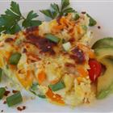
***You can add any type of veggies that you enjoy. Mushrooms, onions, zucchini or peas are often choices for additions. You can vary the cheese and sometimes people add meat too. ***
INGREDIENTS:
6 (24 slices total) slices bacon or pancetta, chopped  1 tablespoon (4 Tbl total) olive oil  1 ½ cups (6 cups total) chopped hot & sweet peppers  salt and ground black pepper to taste | ½ teaspoon (2 tsp total) red pepper flakes  ½ Cup (6 cups total) of Fresh Spinach - torn  1 ½ cups (6 cups total) cubed cooked potatoes  12 (48 total) eggs, beaten  ½ cup (2 cups total) shredded Cheddar Cheese

DIRECTIONS:
1.  2.  3.  4.  5.  6. | Put a large pot of water on to boil. Scrub the skins of the potatoes. Do not peel. Cube potatoes into ½ inch cubes. Carefully put cubed potatoes into large pot of boiling water. Simmer for about 15 minutes. Be watchful that the pot doesn’t boil over!  Chop up bacon into small bite size pieces. Set aside.  Chop all peppers into ½ inch by ½ inch strips. Set aside.  Tear spinach into smallish pieces. Set aside.  Place about ½ - ¾ cup of bacon in a large skillet over medium heat. Cook until bacon is nearly crisp, 5 to 7 minutes.  Add 1 ½ cup peppers; cook and stir over medium heat until softened, about 3 minutes. Season with salt, black pepper, and red pepper flakes; stir to combine.
7. | Add 1 ½ cup potatoes and stir until warmed through, about 2 minutes. Pour in 12 beaten eggs and slowly stir to form large, soft curds, about 5 minutes. Sprinkle ½ cup cheese and ½ cup spinach over the top and stir gently to incorporate.
8. | Set oven rack about 6 inches from the heat source and preheat the oven's broiler.
9. | Place pan under the preheated broiler and cook until the top is set and cheese is browned, about 5 minutes.

Banana Crumb Muffins

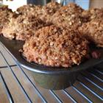 | Prep Time: 15 Minutes Cook Time: 20 Minutes Ready In: 35 Minutes Servings: 30
"A basic banana muffin is made extraordinary with a brown sugar crumb topping that will melt in your mouth."
INGREDIENTS:
2 cups all-purpose flour  2 ½ cups whole wheat flour  1 tablespoon baking soda  1 tablespoon baking powder  1 teaspoon salt  9 bananas, mashed  2 ¼ cups white sugar | 3 eggs, lightly beaten  1 cup butter, melted  TOPPING  1 cup packed brown sugar  ¼ cup and 2 tablespoons all-purpose flour  1/4 teaspoon ground cinnamon  3 tablespoons butter
DIRECTIONS:
1.  2. | Preheat oven to 375 degrees F (190 degrees C).  Line 3 muffin pans with muffin papers.
3.  4.  5.  6. | In a large bowl, mix together the 2 cups of all-purpose flour and the 2 ½ cups of whole wheat flour, baking soda, baking powder and salt.  In another bowl, beat together mashed bananas, sugar, egg and melted butter.  Stir the banana mixture into the flour mixture just until moistened.  Spoon batter into prepared muffin cups.
7. | In a small bowl, mix together brown sugar, ¼ cup and 2 tablespoons flour and ¼ cinnamon. Cut in 3 tablespoons of butter until mixture resembles coarse crumbles. Sprinkle topping over muffins.
8. | Bake in preheated oven for 18 to 20 minutes, until a toothpick inserted into center of a muffin comes out clean.

Health Nut Blueberry Muffins

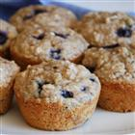 | Prep Time: 15 Minutes Cook Time: 15 Minutes Ready In: 30 Minutes Servings: 36
"Whole wheat flour, oats and wheat germ lend a hearty texture to these delicious muffins. An awesome healthy alternative to the usual blueberry muffin."
INGREDIENTS:
2 ¼ cups all-purpose flour  2 ¼ cups whole wheat flour  2 ¼ cups white sugar  3/4 cup oat bran  3/4 cup quick cooking oats  3/4 cup wheat germ  1 tablespoon baking powder  1 tablespoon baking soda | 3/4 teaspoon salt  3 cups blueberries  1 ½ cups chopped walnuts  3 bananas, mashed  3 cups buttermilk  3 eggs  3 tablespoons vegetable oil  3 teaspoons vanilla extract
DIRECTIONS:
1.  2. | Preheat the oven to 350 degrees F (175 degrees C).  Line 3 muffin tins with paper muffin cups.
3.  4.  5.  6. | In a large bowl, stir together the all-purpose flour, whole wheat flour, sugar, oat bran, quick-cooking oats, wheat germ, baking powder, baking soda and salt. Gently stir in the blueberries and walnuts.  In a separate bowl, mix together the mashed banana, buttermilk, egg, oil and vanilla.  Pour the wet ingredients into the dry, and mix just until blended.  Spoon into muffin cups, filling all the way to the top.
7. | Bake for 15 to 18 minutes in the preheated oven, or until the tops of the muffins spring back when lightly touched.

'SMITTEN KITCHEN'S BIG CLUSTER MAPLE GRANOLA
YIELD: | makes about 14 cups
ACTIVE TIME: | 10 minutes
TOTAL TIME: | 1 1/2 hours

Ingredients
- 10 cups Quick Cook rolled oats
Make 2 batches.
The recipe here is already doubled from the original. But if we double it again – it will be too hard to deal with.
- 2 cups sweetened shredded or flaked coconut
- 2 cups almonds, coarsely chopped
- 1/2 cup toasted wheat germ
- 4 tablespoons olive oil
- 1/2 teaspoon coarse salt
- 1 cup maple syrup
- 1 cup Honey
- 1/2 teaspoon ground cinnamon
- 4 large egg whites
- 3 cups (215 grams) dried cherries, cranberries or another dried fruit, dice if they are large pieces

Procedures
  - Preheat your oven to 300 degrees.
  - Combine all ingredients EXCEPT the egg white and dried fruit in a large bowl, tossing to coat evenly.
  - Whisk the egg white in a small bowl until frothy. Stir into the granola mixture, distributing it throughout.
  - Spread it in a single layer on a parchment-lined baking sheet.
  - Bake for 45 to 55 minutes. About halfway through the baking time, use a large spatula to turn over sections of the granola carefully, breaking them up as little as possible. Rotate the pan if granola is baking unevenly.
  - When it is evenly browned and feels dry to the touch, transfer the pan from the oven to the cooling rack. Cool completely.
  - Once it’s completely cool, break up granola into whatever size clusters delight you. Sprinkle in dried fruit.
  - The granola keeps at room temperature in an airtight container for 2 weeks. It keeps even longer in the freezer.

