“Gator Bites”
Bite–sized information (from A-Z) for Allegheny’s Newest Staff Members

Standard office hours are Monday – Friday 8:00-12:00 p.m. & 1:00-5:00 p.m.

All phone numbers on campus begin with (814) 332 – xxxx

First Weeks of Employment…

- Schedule your appointment with Human Resources
- Obtain your office & exterior building keys
- Obtain your parking permit
- Obtain your Employee photo ID card
- Locate your office/work space
- Determine the status of your office computer (including your username/password)
- Log onto Allegheny’s Network
- Obtain your office phone & set your voice mail message
- Locate your campus mailbox, copy/fax machine, break/lunch room, restrooms, etc.
- Order your office supplies
- Request a mentor (see HR packet)
- Visit Brooks & McKinley’s dining halls
- Take a campus tour
- Don’t be afraid to ask questions!

A
The Administrative Advisory Committee (AAC)

The Administrative Advisory Committee (AAC) is elected to communicate the interests and opinions of exempt (salaried) employees and acts as a liaison to the Administrative Executive Committee (AEC). The committee is comprised of eleven exempt employees. Representa- tives are elected by their peers to serve a two-year term of office. AAC meets regularly and members of the campus community are wel- come to attend. AAC meets one day a month from September through May. Additional information can be found at the AAC website at http://sites.allegheny.edu/committees/administrative-advisory-committee/.

ALLEGHENY MAGAZINE

The Allegheny Magazine is published three times a year for alumni, parents, and friends of the College. A recent version can be viewed online at http://sites.allegheny.edu/magazine/. Please contact Rick Stanley (x4395) with any questions or ideas for a future story.

B
BOOK STORE

Employees receive a 10% discount with their Employee ID Card. Book Store hours are Monday-Friday 9:00-5:00 p.m. & Saturday’s 10:00-2:00 p.m. Please contact the Book Store (x5369) with any questions or view their website http://sites.allegheny.edu/bookstore/ for additional information.

BUILDING COORDINATORS

Building coordinators are a wealth of information and are a great resource! If they do not know the answers to your questions, they can often time direct you to someone who can, please ask! A list of building coordinators can be viewed at http://sites.allegheny.edu/confer- ence/campus-facilities/facility-contacts/.

C
CALENDAR (ACADEMIC)

This calendar provides significant academic dates, from the opening of the residence halls for new students and the first day of classes, through commencement. Each semester will contain exactly 70 class days, 14 on each weekday (Monday through Friday). Additional information can be found at the following website http://sites.allegheny.edu/dean/academic-calendar/ .

CALENDAR (GOOGLE)

Google Calendar is one part of the “Google Apps for Education” web-based suite of software that includes email, calendar, documents, sites and contacts. Find answers to FAQ’s regarding Google Apps at http://sites.allegheny.edu/computingservices/ tutorials/my-allegheny-apps/ or contact Computing User Services (x2755) with any questions.

CALENDAR (MASTER)

The Master Calendar is the College’s Event Management System that indicates most events on campus for a given day, week, month, or year. Please Note: – not all events that are scheduled, (such as various meetings), are indicated on this
calendar. View the Master Calendar at http://mastercalendar.allegheny.edu/MasterCalendar.aspx.

CAMPUS MAP

A simple guide to the buildings on the campus of Allegheny College. A pdf version is available at http://sitesmedia.s3.amazonaws.com/ visitors/files/2012/05/campusmap.pdf.

CATERING & CATERTRAX (PARKHURST)

Catertrax https://alleghenycollege.catertrax.com/ is Parkhurst’s online system where one can place/track menu orders, view dining hall menus, etc. Dining Hall menus can be viewed at https://alleghenycollege.catertrax.com/shopportal.asp?pageid=11&intOrderI D=&intCustomerID= and the Catering Guide can be viewed at https://alleghenycollege.catertrax.com/upload/AlleghenyCatering- Guide20122013.pdf?intOrderID=&intCustomerID=. Please contact Bill Watts (x4387) with any questions.

CHILDCARE

A good source of advice on child care options are other colleagues with children. You may also want to check the local Meadville-James- town phone directory, as well as the Internet. There is one child care center on campus, Meadville Children’s Center, contact the Center at (814) 337-3355 with any questions.

CHOMPERGRAM

The Chompergram is a calendar of weekend events occurring on campus or in the Meadville community. It is sent out via email every Wednesday morning during the academic year. One can sign up for this announcement at https://alleghenycollege.wufoo.com/forms/chompergram-registration-form/.

COLLEGE MEDIA

The Campus (newspaper) can be viewed online at http://alleghenycampus.com/and has been Allegheny College’s student newspaper since 1876. The Campus newspapers can be found throughout campus and are published every Friday during the academic year, except during break and final exams. Allegheny College’s non-commercial, student-run college station, WARC 90.3FM, and their corresponding website http://sites.allegheny.edu/warc/ provide additional information.

COMBINATIONS 2020 (STRATEGIC PLAN)

“Our Vision for Allegheny College - Our Promise” - The strategic plan includes the following areas of focus - Teaching & Learning, Global & Local Diversity, His- tory & Future, and Confidence & Visibility. To request a copy, contact Printing Services (x4367) or view an electronic version at http://sitesmedia.s3.amazonaws. com/president/files/2011/09/2010-Strategic-Plan-forprint.pdf .

COMMITTEES

A list of all official College committees can be viewed at http://sites.allegheny. edu/committees/

COMMUNITY SUPPORTED ARGIULTURE (CSA)(OFF CAMPUS)

Subscribers receive a weekly half-bushel of produce from the Yoder farm when such produce is available and deliveries are retrieved at 950 Grove St. (in Meadville) on Friday nights. A full subscription cycle is April 1st-October 31st. at the rate of $500. Please contact Christopher Bakken (x4388) for additional information.

COMPASS – STUDENT HANDBOOK (THE)

The Compass is the student handbook which is provided by the Dean of Student’s Office (x4356) and mailed from the campus Post Office (x2375). You may contact either office if you are in need of an extra copy.

COMPUTING USER SERVICES (LITS)

You will soon memorize this extension (x2755)! Their services include username/password changes, computing policies, tutorials, support ser- vices, wireless network, training opportunities, Google Apps, videoconferencing, classroom technology, and software support. Please contact the Help Desk (x2755) with any questions or view their website http://sites.allegheny.edu/computingservices for additional information.

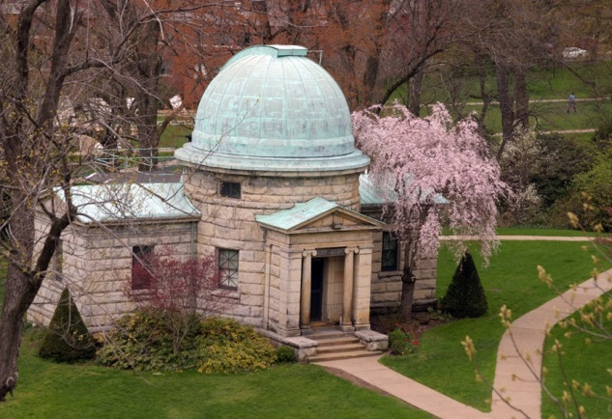
D
DINING CHARGE FORM/SLIP (PARKHURST)

Forms are provided to the cashier for food/beverage expenses as a result of the following business purposes, such as, Admissions Visitor, Admin/Staff Search, Faculty Search, or “other,” at McKinley’s or Brooks Dining Halls. Please contact your supervisor or Parkhurst with any questions.

DINING HALLS

The two dining halls on campus are Brooks Dining Hall and McKinley’s Food Court. Brooks Dining Hall is located in Brooks Hall and offers an all-you-can-eat buffet for $6.75 (lunch) and $7.75 (dinner) and McKinley’s Food Court is located in the Campus Center and offers several a la carte options.

E
EMAIL (GOOGLE)

Google Email is one part of the “Google Apps for Education” web-based suite of software that includes email, calendar, documents, sites and contacts. Find answers to FAQ’s regarding Google Apps at http://sites.allegheny.edu/computingservices/tutorials/my-allegheny- apps/ or contact Computing User Services (x2755) with any questions.

EMERGENCY ALERT SYSTEM (e2Campus)

Our emergency alert system, e2Campus, is coordinated through the Office of Safety and Security. This system allows us to communicate about emergency situations through text messages and emails to members of the campus community who have registered their cell phone numbers and/or email addresses with this service. You may register using the following website https://www.e2campus.net/my/allegh- eny/ or contact Safety & Security (x3357) for additional information.

EMPLOYEE DIRECTORY and DEPARTMENT DIRECTORY

You will be receiving an email (and/or) form from Human Resources asking for your preferences regarding your personal information that will be included in this online directory. The directory is typically available early in the Fall semester. Please contact Human Resource (x2312) with any questions. You can view the Employee Directory or a Department Directory at the following website http://sites.allegheny.edu/hr/employee-directory/. FYI - Printing Services is not permitted to make copies of this directory.

EMPLOYEE HANDBOOK (EXEMPT)

An online version is available from the Human Resources website at http://sites.allegheny.edu/hr/employee-handbooks/exempt-employ- ee-handbook/.

EMPLOYEE HANDBOOK (NON-EXEMPT)

An online version is available from the Human Resources website at http://sites.allegheny.edu/hr/employee-handbooks/non-exempt- employment-handbook/.

EMPLOYEE IDENTIFICATION (ID) CARD

An Allegheny College photo identification (ID) card is issued to each new employee. Arrangements can be made to have this done through the Office of Human Resources during your orientation meeting. You can obtain your ID card from the Security Office located in Newton Observatory once you receive the request form from the Office of Human Resources. The Employee ID card will provide you with privileges at the Bookstore, Library and the Wise Center.

EMPLOYEE (AND FAMILY) PICNIC

The annual employee (and family) picnic takes place in May and is held in Schultz Banquet Hall, Schultz Patio, and Bentley Lawn (weather permitting). Details will follow prior to this event. Please contact Conference & Events (x3101) with any questions.

F
Forms often used across campus

http://sites.allegheny.edu/forms/

G
GAME ROOM

Employees can sign out 4 movies (at one time) up to 48 hours for free from the Game Room – Campus Center 2nd floor. You must present your Employee ID Card to sign them out. Please contact the Game Room (x2373) with any questions. Additional information is located at http://sites.allegheny.edu/studentinvolvement/game-room/.

GATOR CASH (DOWNTOWN MEADVILLE)

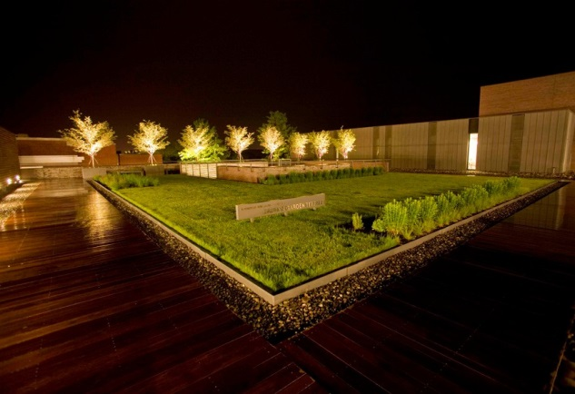
Faculty, staff, and students can now visit several local businesses including, Pizza Villa, the Market House Grille, Creative Crust, and the Whole Darn Thing, as they all accept Gator Cash. Funds can be pre-deposited in
the Gator Cash account at Financial Services. Please contact Financial Services (x2311) with any questions.

GATOR DAYS

One day each semester has been set aside as a day with no scheduled classes or extracurricular activities so that students would be free to take advantage of this opportunity to explore what Allegheny has to offer. Please view the following web- site http://sites.allegheny.edu/gatordays/ for additional information.

GATOR LICENSE

Anyone who operates a college owned van, (min-van, 12 or 15 passengers), must have a current Gator license in their possession. Gator license classes are offered throughout the academic year and are advertised on “My Allegheny.” For license information contact Officer Robert Wright (x3352).

“GOOD MORNING, ALLEGHENY”

An event that is hosted by various Offices/Departments throughout the academic year to highlight specific programs, employees, award ceremonies, etc. This event usually takes place on the 2nd Thursday of a month from 9:00-10:00 a.m. Contact Deb Carmen (x4724) for additional details.

H
HOLIDAY LUNCHEON (EMPLOYEE)

An annual holiday luncheon that is provided to all employees (faculty, staff, administrators) and takes place in Schultz Dining Hall just a few days before the Holiday Break (in late December). All employees are invited to attend this event, where there is a grand buffet, door prizes, occasionally live music/entertainment, and everyone receives a free gift! Watch for an email and/or look for an an- nouncement on “My Allegheny” for additional details.

HOLIDAYS (EMPLOYEE)

View the complete schedule of paid employee holidays on the Human Resources website located at http://sites.allegheny.edu/hr/holiday-schedule/ . Please Note: Breaks in the Academic Calendar (the schedule of classes) vary from this schedule.

HUMAN RESOURCES

Contact Human Resources (x2312) for information or questions regarding payroll, medical/dental/vision benefits, retirement, disability, life insurance, tuition benefits, employee handbooks, FMLA, Employee Wellness Task Force, the holiday schedule, performance reviews, and so much more! Their website is located at http://sites.allegheny.edu/hr/about-human-resources/.

I
IMPORTANT DOCUMENTS

- Academic Calendars – appears in Course Catalogue
- Building Coordinators – appears on the Conference & Events website
- Campus Climate Final Report – appears on the Faculty Resources website
- Campus Map – appears on the Visitor’s Center website
- Combinations 2020 – appears on The Office of the President’s website
- Employee Directory – appears on the Human Resources website
- Organization Chart – appears in the Non-Exempt Employee Handbook – Appendix A
- Parkhurst Catering Guide – appears online under Dining Hall Menus on My Allegheny
- Parking Map – appears on the Campus Security website
- Social Media Accounts – appears on the Web Communication & Marketing website
- Statement of Community – appears in the Course Catalogue

IMPORTANT FORMS

- Employee Family ID Request Form – appears under Forms on My Allegheny
- New Employee Mentor Program Participation Form – appears in your Human Resources packet
- Parkhurst Dining Charge Form – ask your Building Coordinator or Parkhurst
- Payment Request Form – appears under Forms on My Allegheny
- Printing Service Order Form – appears under Forms on My Allegheny
- Travel/Entertainment/Other Expense Reimbursement Report – appears under Forms on My Allegheny

J
Just ask!

K
Keep an eye on “My Allegheny!”

L
LIBRARY (PELLETIER)

Staff can check out materials from the Library by using their Employee ID Card. Please contact Teresa Pratt (x2898) with any questions. Additional information is located at http://library.allegheny.edu/home.

LUNCH and/or DINNER (OFF CAMPUS)

Off campus, there are a several local eateries where one may find other Allegheny faculty, staff, and/or students:

Casey’s Ice Cream & Candies (http://caseysicecreama.lmsstores.com/m_23.asp?pa=m_23)
Chovy’s Italian Casual (http://www.chovysitaliancasual.com/ourstory.ph)

Compadre’s (http://compadresmex.com/)
Creative Crust (http://www.creativecrust.com/)
Eddie’s Footlong Hotdogs (www.eddiesfootlong.com)
Hank’s Frozen Custard (www.hanksfrozencustard.com)
Montana’s Rib & Chop House (http://meadvilleribandchophouse.com/)
Pampered Palate
(http://pamperedpalate.net/) (within walking distance of campus)

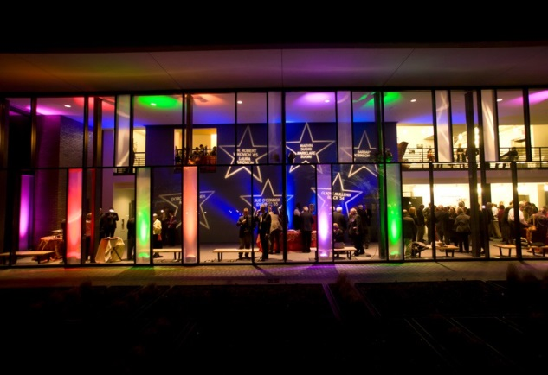
Safari Bar (http://golfatsafari.com/restaurant/index.ph)
Sprague Farm & Brew Works (http://www.sleepingchainsaw.com/brew_works.ht)
Timber Creek Tap & Table (http://www.timbercreektapandtable.com/2012/07/18/handcraft-beers-at-tim- bercreek-tap-and-table/#)
Venango Inn (http://www.venangovalley.com/)
Whole Darn Thing Sub Shop (http://thewholedarnthing.com/)

M
MAIL (EXTERNAL)

All incoming letters/packages should include the name and campus box number of the recipient, as well as, 520 North Main Street, Meadville, PA 16335. Postage will be charged to specific budget lines for external mailings. Please check with your Building Coordinator regarding budget lines for postage and mailing. Please contact the Post Office (x2375) or view their website at http://sites. allegheny.edu/postoffice/ for additional information.

MAIL (INTERNAL/CAMPUS)

Outgoing mail and interoffice communications (usually referred to as “campus mail”) are picked up from and delivered to College offices on a regular schedule (often once between 8:00-12:00 p.m. and once between 1:00 p.m. -5:00 p. m.). Reusable campus mail envelopes are available from departmental offices and from the Post Office. The name of the person and the departmental box number should be used when sending inter-office communications. Please contact the Post Office (x2375) with any questions or view additional information on
their website at http://sites.allegheny.edu/postoffice/.

MENTOR PROGRAM (NEW EMPLOYEES)

Complete the New Employee Mentor Program Participation Form and return it to Human Resources (Box 4) – as provided in your packet from Human Resources. Any interested new employee will be assigned a mentor during the first year of em- ployment “outside” of their campus Dept. or building from a pool of experienced employees. Contact Human Resources (x2312) with any questions.

MOTOR POOL

The college maintains a limited number of vehicles for the use by its employees while they are engaged in college business. In addition, an employee may use his or her own vehicle for college business in accordance with the guidelines provided on the following website http://sites.allegheny.edu/security/motor-pool-requests-and-guidelines/. One may reserve a college vehicle online through EMS Scheduler. Contact Security (x3357) with any questions.

“MY ALLEGHENY”

The “My Allegheny” webpage is one of the ways that College community members can learn of news, events, policy changes, etc. It is updated daily by the Office of Campus Communications and can be viewed at http://sites.allegheny.edu/my/. Interested individuals
may also subscribe to the page to receive a daily update (via email) with the latest postings. Any member of the community may submit an item to be posted on My Allegheny by completing the online form on the My Allegheny home page. Please contact Kathy Roos (x5950) with any questions.

N
NUTRITION & FITNESS COACHING

Did you know as a Highmark Blue Cross/Blue Shield member, you are eligible for free personal nutrition and/or fitness coaching through the Meadville Medical Center’s Wellness Extension at the Mind-Body Wellness Center? View additional details at http://sites- media.s3.amazonaws.com/hr/files/2010/02/PersonalNutritionFitnessCoaching2.pdf .

O
OFFICE ARTWORK

Please contact the Art Gallery (x4365) if you would like to request and choose student and/or faculty artwork to be loaned to you for your office.

OFFICE CLEANING (and HOUSEKEEPING SERVICES)

Offices are cleaned by St. Moritz Building Services for janitorial and related services. Their office hours are Monday-Friday 8:00-4:30
p.m. (x4362). Calls after hours will automatically forward to the on duty manager. All emergencies please call the Office of Safety & Security (x3357). Popular services include recycling removal, trash removal, restroom sanitation, special event services, window cleaning, carpet care, hard surface floor care, construction cleanup, upholstery cleaning, and light changing.

OFFICE COMPUTER

Please contact Computing User Services (x2755) if you have any questions about your office computer.

OFFICE FURNITURE

You can expect your office to contain standard office furniture. Please do not make any structural and/or physical changes without dis- cussing with your supervisor. Physical Plant does keep a storage area full of “recycled” pieces of furniture that your supervisor may want to view before ordering and purchasing new items. One can often find some nice pieces!

OFFICE KEYS and BUILDING KEYS

As a new employee, you may obtain keys required for your job. To obtain keys, you will need to present an authorization form from your supervisor to the Office of Safety & Security. Duplication of keys is prohibited. All keys must be surrendered to the Office of Human Resources prior to the last day of employment. If you have any questions regarding your office (and/or building) keys, please have your supervisor contact Physical Plant (x3868).

OFFICE MAIL

Check with your supervisor where your mailbox is located and where the Department’s mail is received (incoming mail) and sent out (outgoing mail).

OFFICE PHONE

Your office phone number will be published in the Employee Directory along with your name. Your phone should be in working order prior to your arrival or shortly thereafter, if that’s not the case, check with your supervisor or Computing Service’s Help Desk (x2755).

OFFICE SUPPLIES (EATON)

Office supplies can be ordered online via the following website http://www.serviceofficesupply.com/. Please check with your supervisor regarding how to order office supplies.

OFFICE TEMPERATURE CONTROL

Please contact Physical Plant (x3868), if you have any questions regarding these systems.

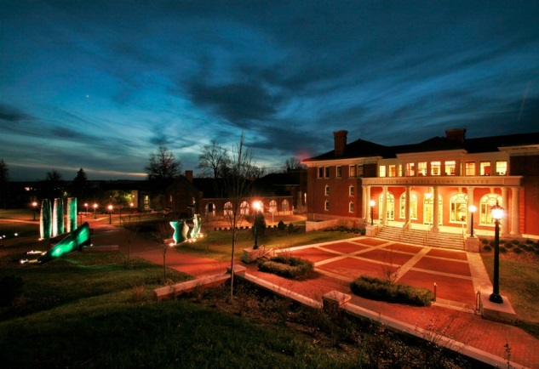
ORGANIZATIONAL CHART

This chart indicates the overall administrative structure of Allegheny College. This chart can be viewed online at http://sitesmedia.s3.amazonaws.com/hr/ files/2012/08/Overview_Updated_072512.jpg .

P
PARKING MAP

The online parking map is available at the following website http://sites.allegh- eny.edu/security/parking/ . Please be mindful of the color coding system and the “gold” lots that are assigned for employee parking.

PARKING PERMIT

Please stop by the Office of Safety & Security to obtain your parking permit. Please contact Jeff Schneider (x3357) with any questions or view the following website http://sites.allegheny.edu/security/traffic-parking-regulations/article-iii-registration-of-vehicles/. You may contact the Office of Safety & Security (x3357) if you find vehicles parked in the wrong lot and Security will place a ticket on the vehicle. Gold stickers are for college faculty, staff, and administrators.

PAYMENT REQUEST FORM

The form is used to reimburse an employee, student, alumni, or other institution/business, etc. for expenses/services rendered. Original receipts must be attached to the completed form and signed by a supervisor or Department Head. Completed forms are sent to Am-
ber Cree in Accounting for future processing. Please contact Amber Cree (x4788) with any questions. Please Note: Once this form is received, reimbursement checks are only “cut” every Thursday. You will need to have your signed/approved form (and receipts) submitted no later than Wednesday of a given week for it be included in the check run produced by Accounting for that week.

PERFORMANCE REVIEW

Expect to complete (and discuss) your annual performance review with your supervi- sor on an annual basis. Timing of annual reviews varies by departments due to work- load and schedules. Please contact Human Resources (x2312) with any questions regarding this process.

PERSONAL CHECK CASHING

Personal checks can be cashed up to $50 in Financial Services – Schultz Hall. Contact Suzie Miller (x 2311) for additional information.

PRINTING SERVICES

Business cards, office stationery, brochures, posters, laminations, programs, etc. are only a few of their services. Contact Printing Services at (x4367) or view their web- site at http://sites.allegheny.edu/printingservices/ for additional information.

R
Report a Concern

Report unethical behavior and policy violations securely and confidentially at - http://sites.allegheny.edu/ciass/bias/

SAKAI

Sakai (https://sakai.allegheny.edu/) is Allegheny’s online course management system. Please contact Michael Hurley (x2890), or Helen McCullough (x3364), with any questions about this system and/or to seek training on this system.

SCHEDULER (EMS)

Scheduler (EMS) (http://scheduler.allegheny.edu/ ) is Allegheny’s internal online software to reserve rooms on campus. Requests for space are created online and then “approved” or “denied” by Building Contacts. A list of Building Contacts can be viewed at http://sites. allegheny.edu/conference/campus-facilities/facility-contacts/. Please contact the Building Contact for the building you are seeking a room, with any questions, during the academic year. Please contact Conference & Events (x3101) with any questions during the
summer only.

SCHOOL DUDE (WORK ORDERS)

School Dude is Allegheny’s online software system to submit work orders and can be viewed at (https://www.myschoolbuilding.com/ myschoolbuilding/msbdefault_email.asp?frompage=myrequest.asp). A tutorial is available at http://sitesmedia.s3.amazonaws.com/ forms/files/2012/01/physplant-workorder-tutorial-0112.pdf. Please contact the Kelly Wright (x3868) with any questions.

SOCIAL MEDIA

Allegheny has several social media accounts; Facebook, Twitter, YouTube, Flickr, and Instagram. For additional information about social media accounts, please view http://sites.allegheny.edu/web/social-media/.

STAFF ADVISORY COMMITTEE (SAC)

The Staff Advisory Committee (SAC) represents the interests, opinions and concerns of the non-exempt staff by communicating these concerns to the Allegheny Executive Committee (AEC). The SAC meets every first (1st) Thursday, members of the campus community are welcome to attend. Representatives are elected by the staff to serve a two-year term of office, which runs from July 1 to June 30, with elections being held in April. The Staff Advisory Committee is composed of eleven (11) full-time staff members. Additional information can be found at the SAC website at http://sites.allegheny.edu/sac/.

STUDENT EMPLOYMENT

Contact Financial Aid (x2701) if you would like to hire student workers in your Office/Dept. There are currently two (2) options available: Federal Work Study or Campus Employment. Students typically work 10-12 hrs/wk during a semester and are often paid minimum wage. To learn more about this process, view the Financial Aid website located at http://sites.allegheny.edu/finaid/student-employment/.

T
THURSTON CLASSIC HOT AIR BALLOON EVENT

2015 marks this 28th annual Classic event! The Classic happens mid-June over a long weekend; Thursday – Sunday; which takes place on campus, at Robertson Field. Food, drinks, and a light breakfast are provided for several of the events. One of the most popular events is the “Night Glow.” Additional information and a full schedule of the events can be viewed at http://www.thurstonclassic.com/ . This is an Allegheny College sponsored event.

TRAVEL/ENTERTAINMENT/OTHER EXPENSE REIMBURSEMENT FORMs

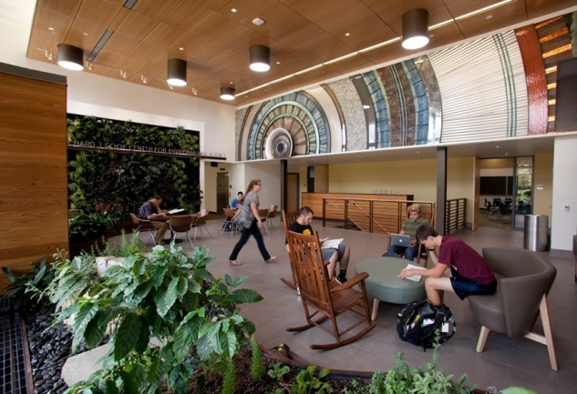
College employees are frequently called upon to travel or entertain guests on College business. Travel and entertainment budgets have been established for these purposes and we encourage faculty and staff to use them in accordance with their professional judgment. The purpose of these guidelines is to ensure consistent use of funds across campus departments. Allowable expenses can be submitted for reimbursement either through the Accountable method or Per Diem method by using the following form http://sites.allegheny.edu/ forms/forms/travel/.

U
Unusual combinations!

V
VERIZON WIRELESS DISCOUNT

Verizon Wireless offers a discount program to the employees of Allegheny College. Existing customers who simply wish to add the discount should visit www.verizonwireless.com/getdiscount to register. When you get to the “check eligibility” page, do not enter your e-mail address but click on the link, “Don’t Have a Work E-Mail Address?” On the next page, click on the link under “Current Verizon
Wireless Customer” that states “If you don’t have a work email address, complete the Discount Eligibility Form.” You will then need to complete both the “Employer” and “Employee” information on the form and submit it to Verizon. or stop by a local verizon store for assistantance. You will also need to upload or fax a copy of your pay stub to Verizon. All other inquiries should be directed to our AC representative, Malinda Schneider at (412) 735-5221 or malinda.schneider@verizonwireless.com.

Voicemail User Guide – see “My Allegheny”

W
WEBADVISOR

WebAdvisor software allows one to view budget lines, approve student time sheets, view employed students, search course sections, view the student directory, etc. Use your standard username and password to access this software.
WebAdvisor is located at on “My Allegheny” or https://webadvisor3.allegheny. edu/WebAdvisor/WebAdvisor?TYPE=M&PID=COREWBMAIN&TOKENI DX=2319459699

WINDSTREAM TELEPHONE DISCOUNT

Windstream Communications offers a discount telephone and Internet services program to all eligible employees. To sign up for the Internet discount, please contact Windstream at 1-800-347-1991 to find out more about DSL rates and plans available to Allegheny employees. To sign up for the telephone discount on your local service, please contact Computing Services (x2755).

WISE CENTER

The Wise Center contains the Mellon pool, an indoor track, weight machines, and fitness classrooms. An Employee ID is required for admittance. Contact Bill Ross (x2316) with questions regarding equipment usage (canoes, kayaks, etc.). View an online brochure at http://alleghenygators.com/documents/2010/11/29/wise_center_brochure_FINAL[1].pdf?&tab=3 .

WORDPRESS

WordPress software allows one to create websites and blogs. Please contact Sean O’Connor (x4783), or Jesse Lavery (x2769), with any questions, and/or to establish access. The login site for Word Press is http://sites.allegheny.edu/idea/wp-login.php?redirect_ to=http%3A%2F%2Fsites.allegheny.edu%2Fidea%2Fwp-admin%2F&reauth=1.

WUFOO

WuFoo software allows one to create online forms. Please contact Jason Ramsey (x2755), with any questions and/or to establish an ac- count. The login site for WuFoo is https://alleghenycollege.wufoo.com/login/ .

X, Y, and Z
Best Wishes for a Successful Year at Allegheny!

Design: Tracy Stevenson, Photography: Bill Owen, Content: Marie Hanaway/Kelly Wright

