Special thanks to our adult helpers for the evening!
Mrs. A. Baer, Miss Antonucci Mr. M. Baer, Mrs. K. Bishop, Mrs. K. Marx, Mrs. E. Bell, Mrs. J. Hlasnick, Mrs. R. Napolitan, Mrs. L. Garafolo

Mrs. L. Garafola

Gateway Middle School
Cooking Club
Homemade versions of your favorites!
Superb Salad Bar
Balsamic Vinaigrette
Ranch Dressing
Herbed Chicken Nuggets with dipping sauces
Mac & Cheese
Cajun Seasoned Oven Fries
Easy Batter Fruit Cobbler
Monster Cookies
Take Home Treats
Chocolate Covered Oreos
The recipes that we used are from the site – allrecipes.com
We modified some of them – ingredients, methods etc. – but the basic recipes are on that site if you want them. We did not change any of the names in case you want to look up the original recipes. If you have any questions – contact Mrs. Baer – abaer@gatewayk12.org

January 2016
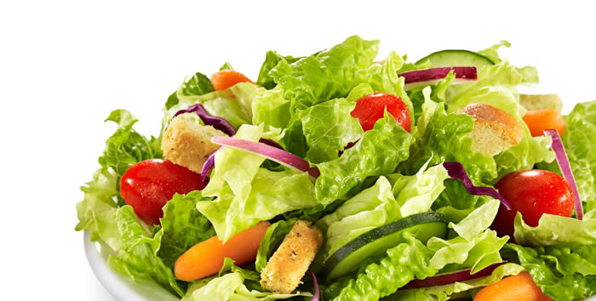
Superb Salad Bar

Make DRESSINGS 1st!

Prep Time: 20 Minutes  Cook Time: 30 Minutes | Ready In: 50 Minutes  Servings: 16

INGREDIENTS:
5 eggs  3 heads Romaine lettuce  4 tomatoes, seeded and chopped  1 cup Shredded Carrots  1 Cucumber | 2 cups shredded cheddar, crumbled  2 avocados - peeled, pitted and diced  6 green onions, chopped  2-3 cups Croutons  1 can chickpeas/garbanzo beans
DIRECTIONS:
1. | To make Hard Boiled Eggs - Place eggs in a saucepan and cover completely with cold water. Bring water to a boil. Cover, remove from heat, and let eggs stand in hot water for 10 to 12 minutes. Remove from hot water, cool, peel and chop.
2.  3.  4.  5.  6.  7. | 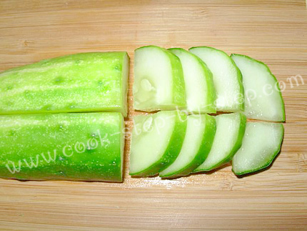  Dice green onions – set aside.  Seed the tomatoes, then chop – set aside.  Peel, pit & dice the avocado – set aside.  Peel carrots, shred on shredder – put in small bowl.  Cut cucumber in quarters lengthwise – then slice it. If you want to, use the mandolin slicer to get nice even slices. (see picture). Put in a bowl & set aside.  Open can of beans – rinse well (use a colander)  Put in s small bowl.
8. | Put chopped lettuce in a large serving bowl.
9.  10. | 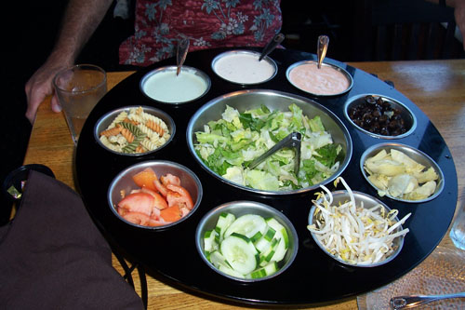  Put shredded lettuce and croutons in small bowls.  Set up a “salad bar” for all of the items – in bowls with  proper serving utensils.

Balsamic Vinaigrette

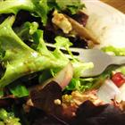 | Rated:  Submitted By: GARYR  Photo By: Dianne  Prep Time: 10 Minutes Ready In: 10 Minutes Servings: 12
"This recipe has the perfect ingredients and the perfect measurements for whipping up the perfect vinaigrette made with white balsamic vinegar. Mix in some chopped fresh herbs if you wish."
INGREDIENTS:
1/3 cup extra virgin olive oil  1/2 cup balsamic vinegar  1 cloves crushed garlic  1 Shallots, minced | 1 teaspoon ground mustard  1 teaspoon Thyme  2 pinches salt  2 pinches ground black pepper to taste
DIRECTIONS:
1. | In a mini processor, mix together olive oil, balsamic vinegar, garlic, shallots, Thyme and mustard powder. Season to taste with salt and black pepper.
MAKE THIS TOO!
Use this recipe to make nugget dip too!
To make it thicker, only use ¼ cup of Buttermilk – keep everything else the same!
Ranch Dressing II

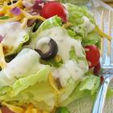 | Prep Time: 5 Minutes Ready In: 35 Minutes Servings: 24
INGREDIENTS:
¾ cup mayonnaise  1 cup sour cream  1 cup buttermilk  1 Tablespoon Olive Oil  1 teaspoon dried chives  2 teaspoon dried parsley  1 teaspoon dried dill weed | 1 teaspoon garlic powder  1/2 teaspoon onion powder  1/4 teaspoon salt  1/8 teaspoon ground black pepper
DIRECTIONS:
1. | In a mini processor mix together the mayonnaise, sour cream, buttermilk, chives, parsley, dill, garlic powder, onion powder, salt and pepper. Cover and refrigerate for 30 minutes before serving.
If you don’t have a mini-processor at home, just whisk together all of the ingredients in a bowl.

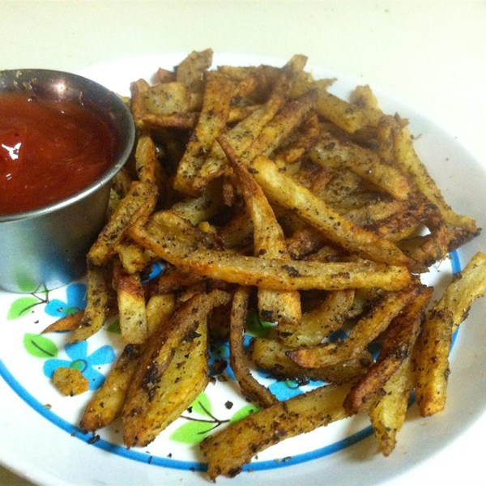
Cajun Baked French Fries
Prep 15 m Cook 45 m Ready In 1 h

Ingredients
- 1/2 cup olive oil
- 2 teaspoon Cajun seasoning
- 2 teaspoon sea salt
- 10 large potatoes, sliced into thin wedges

- 2 teaspoon garlic powder
- 2 teaspoon onion powder
- 2 teaspoon chili powder
Directions
- Preheat oven to 400 degrees F (200 degrees C).
- Mix olive oil, garlic powder, onion powder, chili powder, Cajun seasoning, and sea salt in a large mixing bowl.
- Add potatoes and toss to evenly coat with seasoned oil. Spread coated potatoes in 1 layer onto a baking sheet.
- Bake in the preheated oven for 35 minutes. Stir potatoes with a spatula and continue cooking until crisp, about 10 more minutes.

Yummy Honey Mustard Dipping Sauce

Ingredients
- 1/4 cup honey
- 1 tablespoon lemon juice

- 1 cup mayonnaise
- 1/4 cup prepared yellow mustard
- 2 tablespoons Dijon mustard

Directions
- Mix the mayonnaise, yellow mustard, Dijon mustard, honey, and lemon juice together in a bowl. Cover and chill in refrigerator overnight.

Herbed Chicken Nuggets

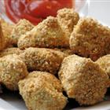 | Servings: 24
."
INGREDIENTS:
16 skinless, boneless chicken breasts  8 eggs, beaten  1 cup parmesan cheese, grated  1/4 cup water  1 tablespoon dried Parsley  2 teaspoons dried thyme  3 pinches crushed red pepper flakes | 2 ½ cups dried bread crumbs, seasoned  1 ½ cups wheat germ  1 tablespoon and 1 teaspoon dried basil  2 teaspoons ground black pepper  1 teaspoon salt  1/4 cup vegetable oil
DIRECTIONS:
1. | Preheat oven to 425 degrees F (220 degrees C). Spray a baking sheet with non-stick cooking spray.
2. | Trim any fat from chicken and cut into chicken strip pieces.
3. | In a bowl beat the eggs with the water. Split into 2 bowls.
4.  5.  6.  7.  8. | Combine the parmesan cheese, parsley, thyme, red pepper, bread crumbs, wheat germ, basil and ground pepper. Stir in the oil with a fork and mix well to distribute evenly. Pour seasoning mixture into a resealable plastic bag.  Add chicken, in small batches to the egg mixture.  Put chicken (in small batches) into the bread crumb mixture bag. Coat chicken.  You’re going to “double bread” the pieces. Put the breaded chicken back into the 2nd bowl of the egg mixture – and then back into the bread mixture again.  Place the coated chicken pieces on a wire rack that you have set onto a cookie sheet.
9. | Bake at 425 degrees F (220 degrees C) for 10 minutes, turn the pieces and cook for an additional 5 minutes.

Old Fashioned Mac and Cheese

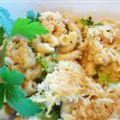 | Prep Time: 20 Minutes Cook Time: 45 Minutes Ready In: 1 Hour 5 Minutes Servings: 18
INGREDIENTS:
2 ½ - 3 boxes (1 lb boxes) uncooked elbow macaroni or other style of noodles that will hold the cheese.  1/2 cup and 2 tablespoons butter  1/4 cup and 1 tablespoon all-purpose flour  5 cups milk | 1 medium onion, minced  salt and pepper to taste (start with ½ teaspoon of each)  4-5 cups of cheese (anything that you have, use a variety for best results = cheddar, swiss, American, Monterey Jack, Colby)
DIRECTIONS:
1. | Preheat oven to 350 degrees F (175 degrees C).
2.  3. | Prepare the macaroni according to package directions. **(use 2 big pots for this)  Finely mince the onion in a mini processor/chopper.
4.  5.  6. | Meanwhile, melt the butter in a small saucepan over medium high heat. Put the minced onion in the pan – cook until the onion becomes clear.  Stir in the flour until a cream colored paste forms.  Then pour in the milk and stir constantly until this comes to a hard boil, then stir for 1 more minute. Remove from heat and set aside.
7.  8. | Whisk in all of the cheese that you shredded until smooth. Stir in the cooked pasta.  Pour into TWO shallow 2 quart baking dishes.
9. | Cover and bake at 350 degrees F (175 degrees C) for 45 minutes. Remove from oven & let sit for 10 minutes before serving.

**If you make this at home, it is not recommended to use pre-grated cheese. There are cellulose additives in that cheese that are put there to stop it from sticking together in the bag. It will make for a “gritty” sauce and won’t be as creamy.

Monster

Cookies
Should make about 40 VERY BIG cookies.

Ingredients
- 1/2 cup butter
- 1 1/2 cups peanut butter
- 4 1/2 cups Old Fashioned rolled oats
- 1 cup mini semisweet chocolate chips
- 1 cup candy-coated milk chocolate pieces

- 3 eggs
- 1 ¼ cups packed brown sugar
- ¾ cup white sugar
- 1 teaspoon vanilla extract
- 1 teaspoon corn syrup
- 2 teaspoons baking soda

Directions
- Preheat oven to 350 degrees F (175 degrees C).
- In a very large bowl, beat the eggs.
- Add the remaining ingredients in order, mixing well.
- Use an ice cream scoop to put on ungreased cookie sheet. Bake for 12 to 15 minutes. DO NOT overbake.
- Let cool on the cookie sheet for 1 minute then move to the cooling rack.

*** At home, you can add in nuts, raisins, craisins etc. Feel free to “play” with the additions

Easy Batter Fruit Cobbler

Rated:
Servings: 8 - 12
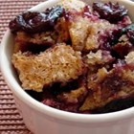
INGREDIENTS:
1/2 cup butter  1-1/2 cups all-purpose flour  1-1/2 cups sugar  2 teaspoons baking powder  1/2 teaspoon salt  1-1/2 cups milk  2 Tablespoons of sugar | 4 cups of sliced fresh peaches or whole blueberries, strawberries, raspberries, blackberries  or a combination of fruits  or a  12-ounce package of frozen fruit
DIRECTIONS:
1. | Adjust oven rack to upper-middle position, and heat oven to 350 degrees.
2. | Put butter in an 8-inch square or 9-inch round pan; set in oven to melt. When butter has melted, remove pan from oven.
3.  4.  5. | Whisk flour, 3/4 cup of sugar, baking powder and salt in small bowl.  Add milk; whisk to form a smooth batter.  Pour batter into pan, then scatter fruit over batter. Sprinkle with remaining 2 Tablespoons of sugar.
6. | Bake until batter browns and fruit bubbles, 50 to 60 minutes. Serve warm or at room temperature with a dollop of whipped cream or a small scoop of vanilla ice cream, if desired.

Chocolate Covered Oreos
Put chocolate in microwave safe bowl. If you have a 4 cup glass measuring cup or larger – it works perfectly.
Put chocolate in microwave for 1 minute. Stir with spatula. Melt chocolate in 30 second intervals in the microwave. Stirring with a spatula after every 30 seconds. Once it has satisfactorily melted, you’re ready to start!
Grasp an Oreo on the SIDES with the tongs. Fully dip cookie into the chocolate. Use the edge of the bowl or cup to thoroughly wipe off the bottom of the cookie. The less chocolate on the bottom, the neater they will be.
Place cookie onto waxed paper. After you have about 5 on the tray – decorate with the decorations. When tray is full – place in the refrigerator to cool. Or just leave on the counter if you aren’t rushed for time like we are in cooking club
Hints & Tips:
Before putting the chocolate in the bowl – make sure it is 100% dry – even 1 drop of water can ruin your chocolate. Make sure the spatula that you are stirring with is also 100% dry
Use tongs to grasp the cookie and dip it into the chocolate. That way, you can wipe off a lot of the chocolate from the bottom of the cookie. This leaves for a neater appearance for the finished product – but still leaves plenty of chocolate-y goodness.
1 lb of chocolate *should* cover about 50 Oreos.
In my opinion, Merckens chocolate discs are the easiest to work with when melting chocolate. Luehm Candy Company in Irwin – right by Norwin High School – is the closest and cheapest place to get them.
You CAN use regular chocolate chips – but they are just a little tougher to work with and don’t stay as melt-y as long – so you make have to reheat midway before covering the rest of the cookies.
For toppings/decorations:
Try crushed candy canes, sprinkles/jimmies, mini M & M’s
Colored sugar is a little tough – it tends to “sink” into the chocolate.
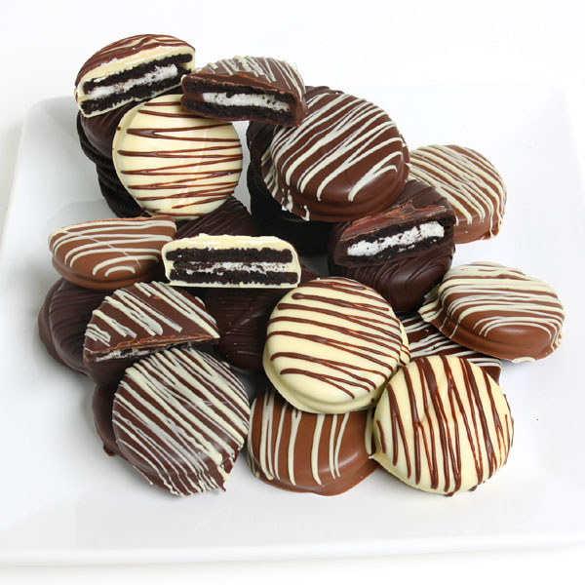
After the milk chocolate cools, you can try to melt some white chocolate and drizzle it across the top of the cookies to make a different effect. You can try to spoon the melted white chocolate into a sandwich baggie and snip off the corner to make it easier to decorate with.

