Special thanks to our adult helpers for the evening;
Mrs. A. Baer, Mr. M. Baer, Miss J. Antonucci, Mrs. L. Garofalo, Mrs. E. Bell, Mrs. J. Hlasnick, Mrs. R. Napolitan, Ms. A. Havrilla

December 18, 2015

Gateway Middle School
Cooking Club
Sweet Treats
Recipes that will be prepared for taking home:
Reindeer Food
Decorated Chocolate Covered Pretzel Rods
Chocolate Peanut Butter Meltaways
Candy Brownie Bites
Included in packet but not made:
Chocolate Pretzel Treats
Hot Chocolate Mix Gift Cones
Dinner Prepared for your eating pleasure:
Homemade Pizzas with assorted toppings

If you have any questions – contact Mrs. Baer – abaer@gatewayk12.org

Reindeer Food

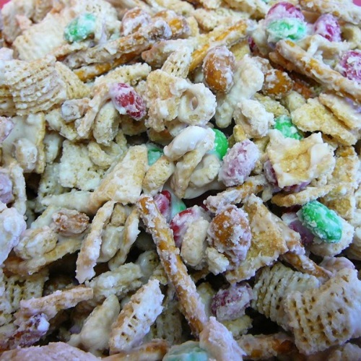 | Prep Time: 20 Minutes Ready In: 50 Minutes Servings: 24
INGREDIENTS:
1 (20 ounce) package miniature pretzels  1 (17.5 ounce) package crispy corn  cereal squares (such as Corn Chex®)  1 (16 oz) jar salted dry-roasted peanuts | 1 (14 ounce) package candy-coated milk  chocolate pieces (such as M&M's®)  24 ounces white chocolate chips or white chocolate melting wafers.
DIRECTIONS:
1. | Cover a large area of counter space with waxed paper and tape it down.
2. | Mix pretzels, corn cereal squares, peanuts, and candy-coated milk chocolate pieces together in a large bowl.
3. | Melt white chocolate in the top of a double boiler over simmering water, stirring frequently and scraping down the sides with a rubber spatula to avoid scorching. Pour melted white chocolate over pretzel mixture; stir to evenly coat. Quickly transfer mixture to the prepared waxed paper and spread in a thin layer; cool completely. Break into pieces and store in an airtight container.

Feel free to “play” with this recipe. Try these additions/substitutions:
Add in toasted O’s cereal (like Cheerios) instead of some of the Chex cereal
Try mint M & M’s
Add in crushed candy canes
Use a mix of melted white chocolate and milk chocolate

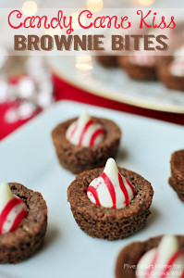
t

Candy Brownie Bites
Prep 25 m Cook 20 m Ready In 45 min

Ingredients
- 1 cup butter
- 1 cup white sugar
- 1 cup brown sugar
- 4 eggs
- 2 teaspoons vanilla extract
- 1 cup unsweetened cocoa powder
- 1 cup all-purpose flour
- ½ teaspoon baking powder
- ½ teaspoon salt
- 45-60 UNWRAPPED, FROZEN candies.

Directions
- Preheat oven to 350 degrees F (175 degrees C).
- Put mini muffin liners in 48 of the mini muffin cups.
- In a large, glass, microwave safe bowl, melt 1 cup butter.
- DO NOT USE AN ELECTRIC BEATER or MIXER. Remove the melted butter from microwave, and stir brown sugar, white sugar, eggs, and vanilla.
- Beat in the cocoa, flour, salt, and baking powder. DO NOT OVERMIX.
- Use the cookie scooper and put portions of the batter into the mini muffin liners. Do NOT overfill. You should be able to get 44-48 brownie bites from this batch.
- Bake in preheated oven for 20-22 minutes. Do not overcook.
- Let the brownies cool for about 1 minute.
- Put the unwapped candies into the brownies.
- Remove the brownie bites to a cooling rack so that they can cool.

Chocolate Covered Pretzel Rods
Put chocolate in crockpot. Put it on low – KEEP MONITORING IT! Mix it every 10 minutes or so.
Pick up a pretzel rod. Fully dip the pretzel into the chocolate. Use the edge of the bowl or cup to thoroughly wipe off a lot of the chocolate.
Place pretzel onto waxed paper. After you have about 5 on the tray – decorate with the decorations. When tray is full – place in the refrigerator to cool. Or just leave on the counter if you aren’t rushed for time like we are in cooking club
Hints & Tips:
Before putting the chocolate in the crockpot– make sure it is 100% dry – even 1 drop of water can ruin your chocolate. Make sure the spatula that you are stirring with is also 100% dry
1 lb of chocolate *should* cover about 60 mini pretzel rods
In my opinion, Merckens chocolate discs are the easiest to work with when melting chocolate. Luehm Candy Company in Irwin – right by Norwin High School – is the closest and cheapest place to get them.
You CAN use regular chocolate chips – but they are just a little tougher to work with and don’t stay as melt-y as long – so you make have to reheat midway before covering the rest of the cookies.
For toppings/decorations:
Try crushed candy canes, sprinkles/jimmies, mini M & M’s
Colored sugar is a little tough – it tends to “sink” into the chocolate.
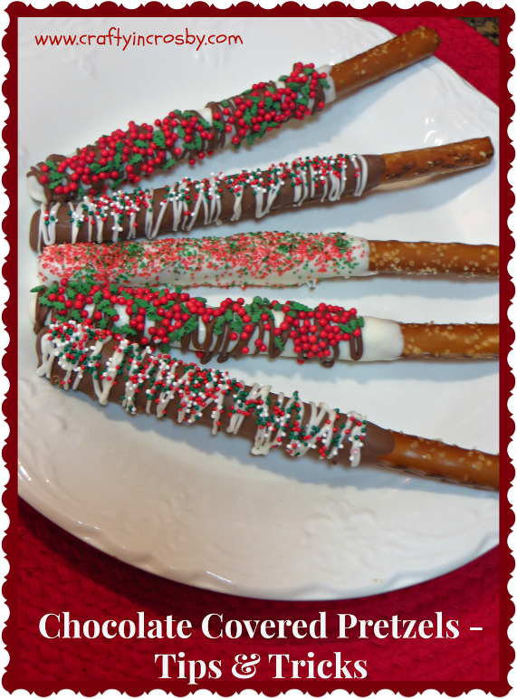
After the milk chocolate cools, you can try to melt some white chocolate and drizzle it across the top of the cookies to make a different effect. You can try to spoon the melted white chocolate into a sandwich baggie and snip off the corner to make it easier to decorate with.
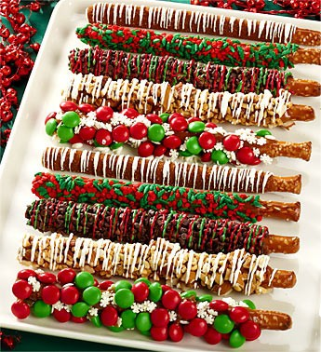
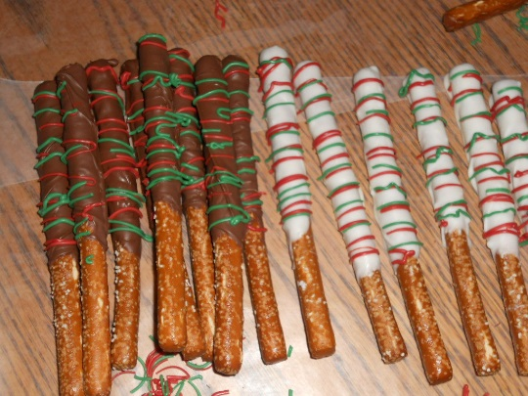

Peanut Butter Meltaways
Ingredients
NOTE:
6 oz is equal to about 1 cup if you are using regular size white chocolate chips.
3 oz = ½ cup
- 6 oz White Chocolate Chips or white chocolate melting wafers
- 3 oz Semisweet Chocolate Chips
- 1/2 cup Peanut Butter
- 1 tbsp Coconut Oil (shortening can be used, we are using coconut oil b/c it is healthier and not a chemical based product)
Instructions
- 1. Combine all of the ingredients, cover and microwave for 90 seconds.
- 2. Remove cover, stir and microwave 30 additional seconds.
- 3. Stir until smooth.
- 4. Put the tiny candy cups onto a cookie sheet. Set out 48 of them.
- 5. Using the teeny, tiny scooper put the mix into the tiny candy cups.
- 6. Put an m&m or a candy cane decoration on top of some.
- 6. Place the cookie sheet into the refrigerator until set.
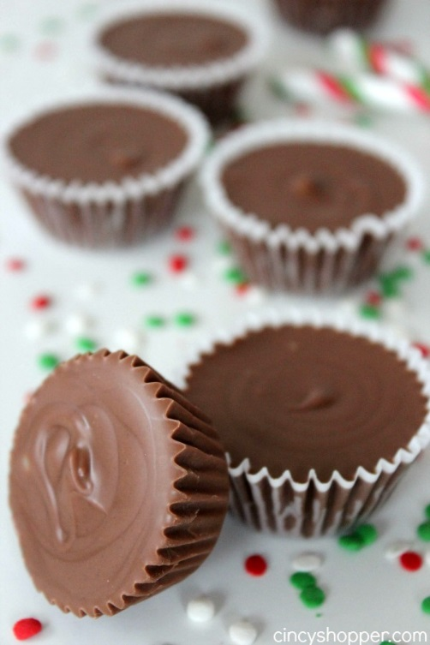
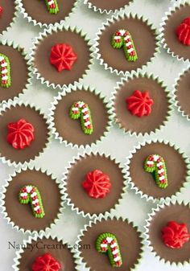

Hot Chocolate Mix

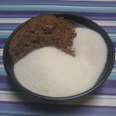 | Rated:  Prep Time: 10 Minutes Ready In: 10 Minutes Servings: 16
INGREDIENTS:
3 cups nonfat dry milk powder  3/4 cup white sugar | 1/2 cup unsweetened cocoa powder  1/8 teaspoon salt
DIRECTIONS:
1.  2. | Mix milk powder, sugar, cocoa, and salt together in a bowl. Transfer mix to an airtight container.  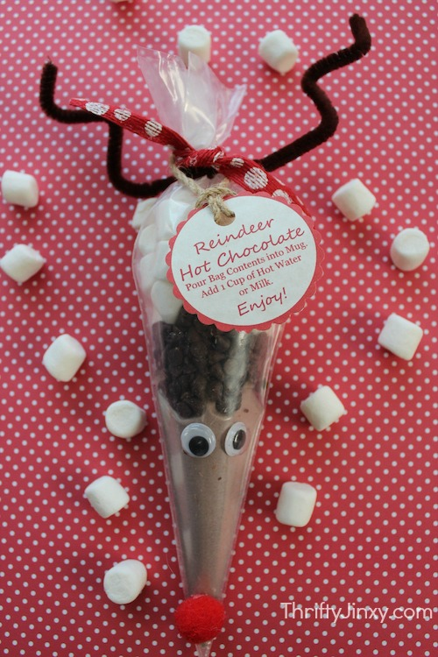  When ready to use, mix 3-4 Tbs of mix into one cup of hot water or hot milk. Stir.
DIRECTIONS to make the Reindeer Cone
Pour dry hot chocolate mix into piping bag. Put in enough for 2-4 servings. (Adjust instruction tag on the bag to reflect how much you included.)
Layer in mini chocolate chips.
Add layer of mini marshmallows.
Twist and tie off with ribbon.
Glue Pom Pom Nose near tip of bag.
Glue google eyes Near the top of the hot chocolate mix.
Wrap Brown Pipe Cleaner around top for antlers and shape.
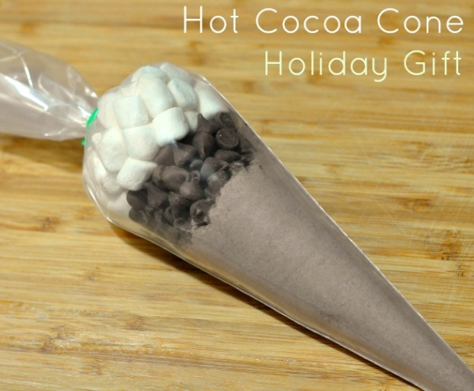
Hot Cocoa Mix
This will make ___ servings of Hot Cocoa.
Heat ____ cups of milk or water. Stir in contents of bag. Enjoy!
Hot Cocoa Mix
This will make ___ servings of Hot Cocoa.
Heat ____ cups of milk or water. Stir in contents of bag. Enjoy!

Tags for you to copy, cut out and attach to the cocoa cones

Chocolate Pretzel Treats

Rated:
Submitted By: LCDOYLE
Photo By: T-bone
Prep Time: 10 Minutes  Cook Time: 2 Minutes | Ready In: 22 Minutes  Servings: 40

INGREDIENTS:
1 (15 ounce) package small pretzel twists  1 (8 ounce) package milk chocolate candy kisses (such as Hershey's Kisses) | 1 (1.69 ounce) package candy-coated  milk chocolate pieces (such as M&M's®)
DIRECTIONS:
1. | Preheat oven to 175 degrees F ( 80 degrees C).
2. | Arrange pretzels on a baking sheet. Place a candy kiss on the center of each pretzel.
3. | Warm pretzels in the preheated oven until candy kiss is shiny and slightly softened, 2 minutes.
4. | Place a candy-coated chocolate piece atop the candy kiss on each pretzel; press down. Chill in the refrigerator for 10 minutes.

Variations:
Use Rolo candies instead of the Kisses.
Try the seasonal Kisses that are available. I would NOT recommend the ones with the soft truffle centers. I would imagine that when they would be put in the oven, they would melt too much and make a mess!

